Measure. The level of measurement for the variable (e.g., **nominal**, **ordinal**, or scale). Some procedures in SPSS treat categorical and scale variables differently. By default, variables with numeric responses are automatically detected as “Scale” variables

## Difference between nominal, ordinal and scale in SPSS

In SPSS input file, it is required to define the variables on the basis of nominal, ordinal or scale. At the same time, it needs to code the variables according to the categories those variables are divided into.

#### *Nominal*

A variable can be treated as **nominal**when its values represent categories with no intrinsic ranking. For example the department of the company in which an employee works. Examples of nominal variables include region, zip code, or gender of individual or religious affiliation. The nominal scale can also be coded by the researcher in order to ease out the analysis process, for example; M=Female, F= Female.

#### *Ordinal*

A variable can be treated as **ordinal** when its values represent categories with some intrinsic ranking. For example, levels of service satisfaction from highly dissatisfied to highly satisfied. Examples of ordinal variables include a degree of satisfaction among the consumers, preference degree from very high to very low, and degree of concern towards the certain issue. Generally, it is preferable to assign numeric codes to represent the degree of something among respondents. For example 1=Highly satisfied, 2=satisfied, 3= neutral, 4= dissatisfied, 5= highly dissatisfied.

#### *Scale*

A variable can be treated as **scale** when its values represent ordered categories with a meaningful metric, so that distance comparisons between values are appropriate. Examples of scale variables include age in years, and income in thousands of Rupees, or score of a student in GRE exam. For example in a classroom of 60 students, each one would have given GRE entrance test, and therefore Scale is used to determine the average score for the class, or the highest and lowest score in the class so on and so forth.

Descriptive Statistics

1. Aims and Learning Objectives

* The aim of this workshop is to use SPSS to describe a sample data set.

After this session you will be able to:

* Describe data using SPSS.
* Distinguish between the Frequencies and Descriptive commands in SPSS.
* Know when to and how to use the Split File command.
* Read results in the Output Window.
* Use the Output Navigator.

Having now mastered data entry, the next SPSS skill to acquire is carrying out some basic descriptive analysis. In any Research report, the descriptive analysis plays a vital role in supporting the inferential statistics.

2. What constitutes descriptive data?

* As you will recall from your lectures, descriptive data describes the data rather than making inferences, this is the job of the statistical tests you shall be examining in future weeks. Examples of descriptive data:

Measures of central tendency:

Mean,   
Median,   
Mode.

Frequencies:

Total numbers of categories in each condition

3. Frequencies v/s Descriptives

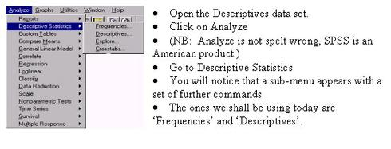

What is the main difference between the Frequencies and Descriptives command?

In short, The ‘Frequencies’ command will count up how many times a component of a variable appears and puts this information into a table. E.g. we may want to know the frequency of shoe size for our sample population.

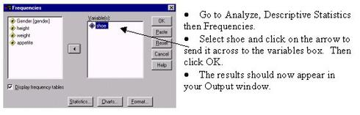

The Frequencies command can also give you the main measures of central tendency.

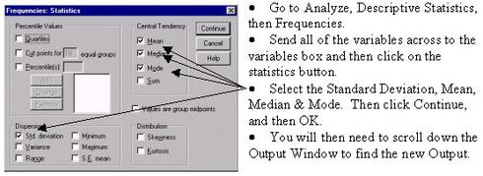

SPSS has put all of the statistics you requested into a neat table.

* As well as displaying the Standard Deviation, Mean, Median & Mode. The Output also produces a long list of frequency tables for each variable, much of which may not be necessarily helpful.

This is where the **‘Descriptives’** command can be more useful, as it shows the measures of central tendency without a frequency breakdown of each variable. However, the **‘Descriptive’** command is unable to show a Median and Mode, for this you must use the Frequency command.

The descriptives command an be found by clicking on the Analyze pull-down menu, selecting the Descriptives command and then clicking on Descriptives. The dialogue box for the descriptives command is similar to the Frequencies dialogue box.

4. Task 1: Using the Descriptives command

Using the Descriptives command, produce the mean and standard deviation for each variable.

5. Using the ‘Split file’ command

* As the data stands, you can only do the statistics on the population as a whole. What if we wanted to get a further breakdown of descriptive statistics not only for each variable, but for gender and age as well? This is actually quite straightforward and does not involve re-entering the data at all.

Go to the ‘Data’ pull down menu and select ‘Split file’.

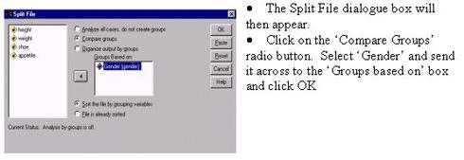

* Now carry out the Descriptives command again, this time sending all the variables across to the variable box with the exception of gender. The Output will now show the descriptive statistics for all of the variables by Gender.